*Core Java - Statements Assignment*

**Instructions:**

Below you will find a series of assignments that you will complete in this exercise. You will need to create a new project folder for this task and name it **Java_Assignment_2_Statements**. You can use the default settings when creating the new project.

For each of the below assignments you will create a new class as specified below and write your code in a **main()** method of that class. You can use the same (default) package when creating each class.

**Assignments**

1. Write a class named **Assignment1** which uses a conditional statement to check if a number is even.
2. Write a class named **Assignment2** which creates an **integer** variable x. Set x to some value. Then write a conditional statement that checks if x is greater than 3. If so, print the message, “x is greater than 3” to the console.
3. Write a class named **Assignment3** which creates an **integer** variable x. Set x to some value. Then write a conditional statement that checks if x is greater than or equal 3. If so, print the message, “x is greater than or equal 3” to the console.
4. Write a class named **Assignment4** which creates an **integer** variable x. Set x to some value. Then write a conditional statement that checks if x is equal to 3. If so, print the message, “x is equal to 3” to the console.
5. Write a class named **Assignment5** which creates an **integer** variable x. Set x to some value. Then write a conditional statement that checks if x is equal to 3. If so, print the message, “x is equal to 3” to the console. Write an associate else-statement that prints the message “x is NOT equal to 3” to the console.
6. Write a class named **Assignment6** which creates a **float** variable x. Set x to some value. Then write an if-statement that checks if x is equal to 3. If so, print the message, “x is equal to 3”. Write an else-if statement to check if x is greater than 5, and, if so, prints the message, “x is greater than 5”. Write another else-if statement to check if x is less than or equal to 0. If so, it prints the message, “x is less than or equal to 0”. Write an else-statement to prints the message, “x is none of the other options”.
7. Write a class named **Assignment7** which uses a **for-loop** to print only the even numbers between 0 and 10, inclusive.
8. Write a class named **Assignment8** which uses a **do-while loop** to print only the odd number between 1 and 9, inclusive.
9. Write a class named **Assignment9** which uses a **while loop** to print the statement “In loop” 7 times.
10. Write a class named **Assignment10** that uses a **for-loop** to navigate through an array of 10 double numbers and prints each element of the array.
11. Write a class named **Assignment11** that uses a double for-loop (a for-loop within a for-loop). The outer loop should navigate through an integer array that has 10 elements corresponding to the numbers 1 through 10, inclusive. The inner loop should count from 1 to 10, and prints the value of the current count multiplied by a the current index of the array. You should end up printing the multiples of 1 through 10 from 1 to 10. Ex: 1*1, 1*2, 1*3…1*10, 2*1, 2*2, 2*3…10*9, 10*10.

**Goal:**

The purpose of this assignment is to provide you practice with writing classes that perform arithmetic operations and makes use of loops. You will utilize the **main()** method of your classes to execute a particular goal of the assignment.

By the end of this assignment, you will have 1 new project folder with 11 classes that meet the requirements mentioned above.

**Helpful Notes**

Project Structure:

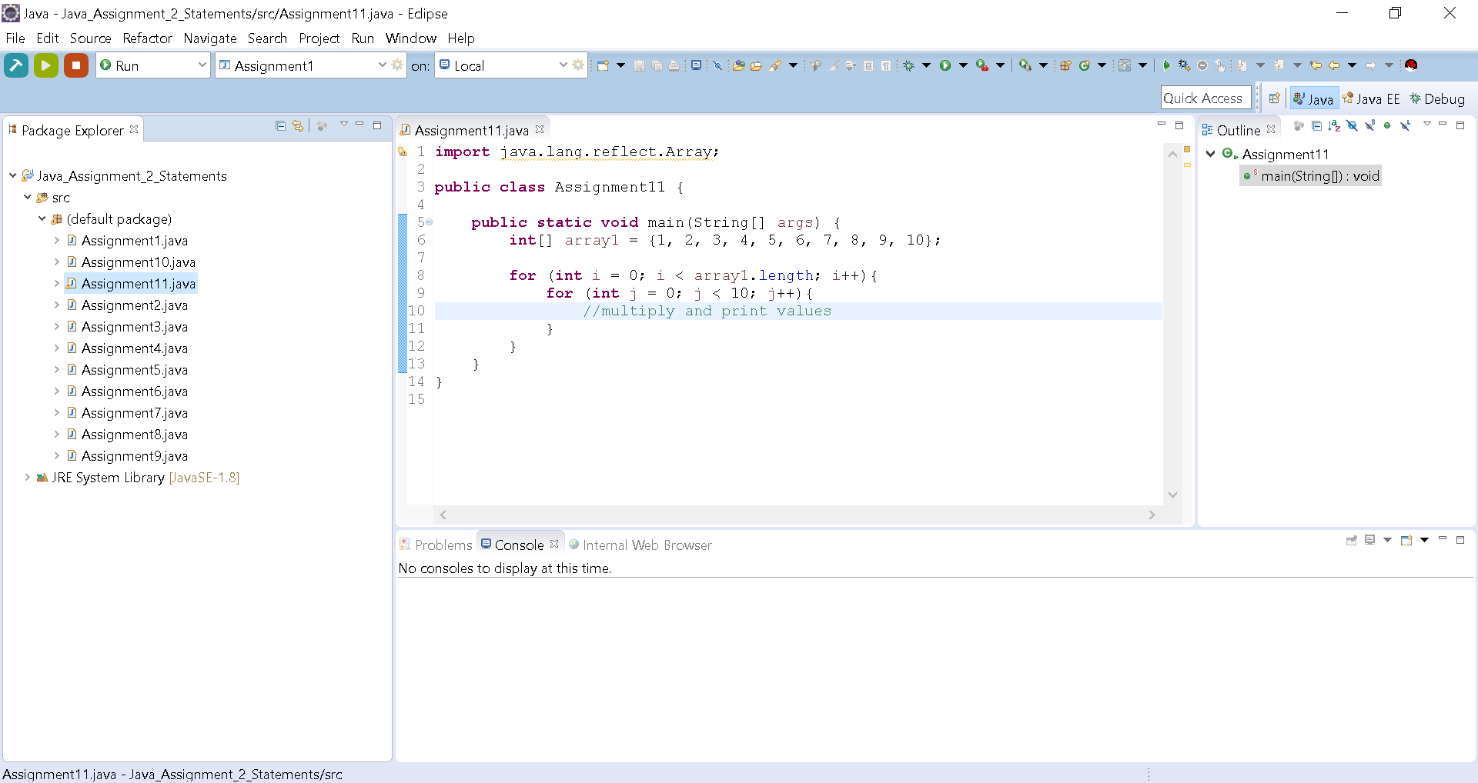

* Your project structure should resemble the above. Note that the name of the project is **Java_Assignment_2_Statements** and all class files are named according to the associated assigned number

Assignment Classes:

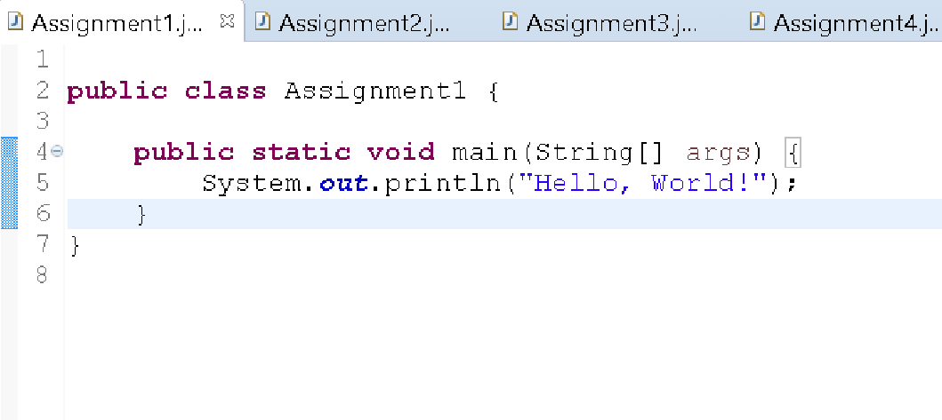

* Notice the indentation of the statement on line 5 to show that it is part of the main() method. Likewise, your code should follow this pattern.

Using a double for-loop:

One unique thing about a double for-loop is that the inner loop has access to the variables and data defined in the outer loop. A note of caution, you should NOT declare the same variable name in the inner loop as the counter in the outer loop.

ex:

|  |
| --- |
| **for** (**int** i = 0; i < array1.length; i++){  **for** (**int** i = 0; j < 10; j++){ //this will mask the ‘i’ in the outer loop |

Instead you should declare a *different variable name*.

ex:

|  |
| --- |
| **for** (**int** i = 0; i < array1.length; i++){  **for** (**int** j = 0; j < 10; j++){ //declares ‘j’ instead of ‘i’ |